MS SQL SERVER
Standard Operating Procedures
(SOP)
Change Login Accounts of SQL Services in sql server 2014

Submitted to



BY



CIS, Wipro Limited

Document Details

Project Name | Innogy SE
Account | CIS
IT Component/Application Title | Releasing Log space from Log files
Current Version | 1.2
List of Contributors | Pradipkumar Kansara, Kiran Bhalekar, Ayushi Gautam, Sivakumar Goud, Pramod Patil
Customer Contact Information

Version History
(All revisions made to this document must be listed in chronological order. All revisions must be approved. Review and Approval can be done by an internal source or by the customer)
Version | Date of Revision | Description | Author | Reviewed By | Approved By
1.0 | 05-12-2017 | Initial Draft | Ayushi Gautam | Pradipkumar Kansara | Santosh Badiger
1.1 | 05-12-2017 | Document Completed | Kiran Bhalekar | Pradipkumar Kansara | Santosh Badiger
1.2 | 10-10-2018 | Updated the content | Pramod Patil | Pradipkumar Kansara | Santosh Badiger

Document Distribution List
S.No | Name and Company | Purpose
1 | RWEIT-SQLDBA | Document is useful for changing sql service login account.

TABLE OF CONTENT
1. Purpose 1
2. Scope 1
3. Changing SQL Service Log on account 1
4. Best Practice 8
5. Reference 8

Purpose
This document is prepared for changing Login account of SQL services in SQL Server Database Administration Services.

Scope
This document is prepared for SQL Wipro sustenance team and provides the concepts, and tutorials to change the login account of SQL service for the administration of the SQL Server database.

Changing Login account of SQL service
There are two ways to change log on account :
- Services.msc
- SQL Server Configuration Manager

STEPS to change Logon account through services.msc
- Login to server > start > run [Windows+R] > services.msc
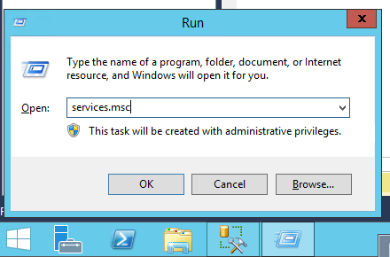
- Go to SQL service

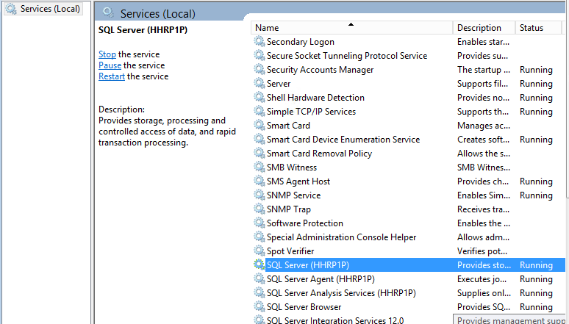

- Right click > properties > Log on Tab > Browse > Put the right service account\group account with password
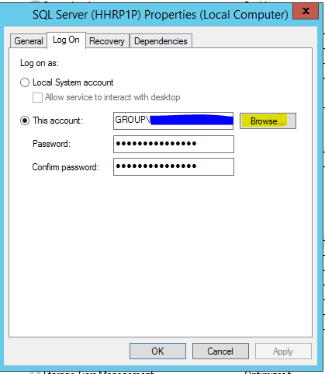

OR
STEPS to change Logon account through SQL Server Configuration Manager

- Go to SQL Server Configuration Manager
- Right click > properties
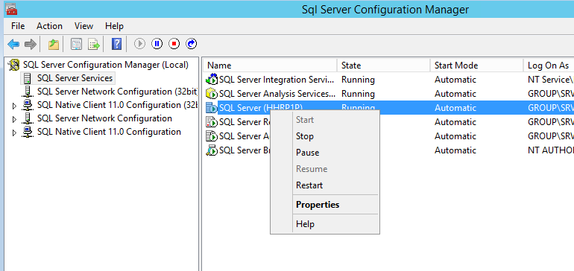

- Log on Tab > Browse > Put the right service account\group account with password 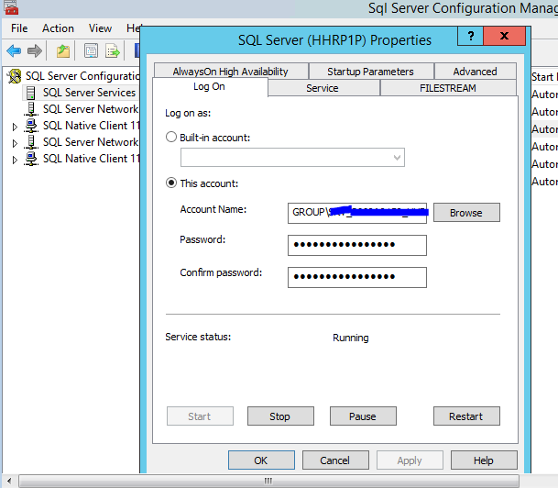
- OK > The log on account is changed now but keep in mind that the change would be effective only after the reboot.
- Reboot the server

Best Practice
- Avoid configuring as local in service account.
- SQL Server service account has “full control” permissions on data, log and backup directories for read and write activities.
- Also, it is better to change the service account from “SQL SERVER Configuration manager”

Reference
https://docs.microsoft.com/en-us/sql/database-engine/configure-windows/configure-windows-service-accounts-and-permissions

